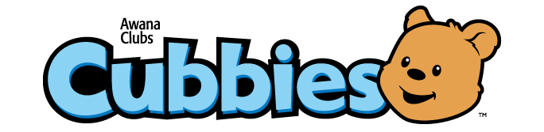
Cornerstone Church of Poway
2016-2017 Calendar
Tuesdays 6:00pm-7:30pm

 | Week 1 | Week 2 | Week 3 | Week 4 | Week 5
September |  | 6  Leader Training | 13  Family Night  (No Drop Off) | 20  Awana Kick Off  First Club Night  Bear Hug A | 27  Team Color Night  Bear Hug B
October | 4  Bear Hug 1 | 11  Parent/Friend Night  Bear Hug 2 | 18  Mustache Night  Bear Hug 3 | 25  Dress Up as a Bible Character  Bear Hug 4
November | 1  Awards Night  Bear Hug 5 | 8  Thank You Cards – Veterans  Bear Hug 6 | 15  Canned Food Drive Team Contest  Bear Hug 7 | 22  No AWANA Clubs  Thanksgiving | 29  Bear Hug 8
December | 6  Bear Hug 9  Snowman Night | 13  Bear Hug 10  Christmas Party | 20  No AWANA Clubs  Winter Break | 27  No AWANA Clubs  Winter Break
January | 3  Birthday Night  (July1-Dec 31)  Bear Hug 11 | 10  Crazy Hair Night  Bear Hug 12 | 17  Awards Night  Bear Hug 13 | 24  Grand Prix Night | 31  Sports Jersey Night  Bear Hug 14
February | 7  Bear Hug 15 | 14  Red and Pink Night  Bear Hug 16 | 21  No AWANA Clubs  Ski Week | 28  Kick Off Missions Month  Bear Hug 17
March | 7  Missions Month  Bear Hug 18 | 14  Super Hero/ Princess Night  Bear Hug 19 | 21  Awards Night  Bear Hug 20 | 28  Pie Your Leader Night  Bear Hug 21
April | 4  Pajamas Stuffed Animal Night  Bear Hug22 | 11  No AWANA Clubs  Spring Break | 18  Bear Hug23 | 25  Drive In Movie Night
May | 2  Nerd Night  Bear Hug 24 | 9  Birthday Night  (Jan. 1-June 30)  Bear Hug 25 | 16  Patriotic Night  Bear Hug 26 | 23  Finish up any Bear Hugs | 30  Awards Ceremony
Awana Conference (for leaders) is October 8. Leader Appreciation Dinner is June 4.
All dates are subject to change. (Refer to emails.) Miranda Davis, AWANA Commander awana@cornerstonepoway.com

